QUALITY MEAT SCOTLAND COMMUNITY MARKETING FUND
APPLICATION FORM
2025/26

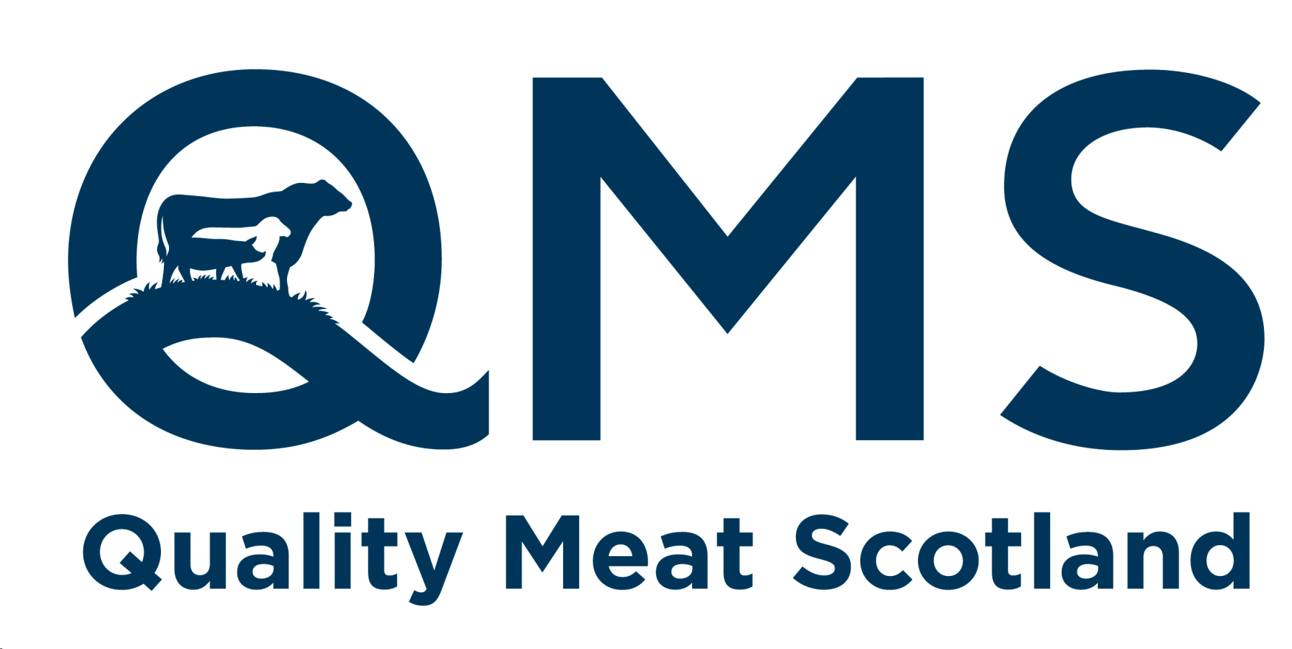
At Quality Meat Scotland, we're committed to supporting initiatives that promote our red meat brands within the industry and communities across Scotland. The Community Marketing Fund is a dedicated resource designed to support local projects and events that educate consumers on the characteristics and encourage the purchase of Scotch Beef, Scotch Lamb and Specially Selected Pork.
Whether you're aiming to enhance awareness, education or engagement, we welcome applications across a diverse mix of activities and locations. Whilst we can’t guarantee support to every initiative, we will review and acknowledge all submissions and respond as quickly as possible.
Simply fill in the form giving as much notice as possible, and we’ll get back to you. Please complete the following as accurately as possible noting the guidelines for applications at the bottom of this form, and email the completed form to info@qmscotland.co.uk where we will aim to acknowledge your application within 5 working days. We welcome applications from all community events but cannot guarantee that we can accommodate your request.
Your Name:
Email address:
Phone number:
Who are you applying on behalf of? (Please state organisation name as relevant):
A brief description of your request, what you need from QMS and when you need it by (eg.. Funding, sponsorship, meat, point of sale material, someone to speak at an event etc)…
What is the date, time and location of the event/initiative:
If relevant, how many people are you expecting will attend?
How will you evaluate the success of your initiative? What are you hoping to achieve from doing it? Please give a brief summary…
Anything else we should be aware of that may be helpful when considering your request?
Guidelines for applications:
- Applications are open to individuals, businesses, organisations or charities linked to the Scottish red meat supply chain. This includes show societies.
- Applications are accepted on a rolling monthly basis at the end of each month and are assessed on merit, focusing on the impact, reach and return on investment on each individual application.
- Applicants will be notified of the outcome of their application within 6 weeks of the application being made.
- There is no maximum cap on award limit, however the total pot is limited, and is awarded on a first come first served basis.

