Injection into the hindquarters can devalue a carcase, no matter what age the animal is when it is injected. This includes calves and lambs.
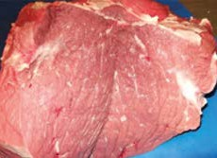 | 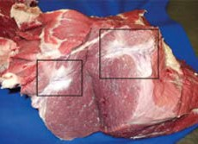
Silverside without muscle degeneration. | Silverside muscle degeneration (Fibrosis) due to injection into the muscle.
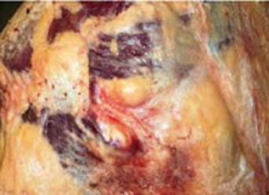 | 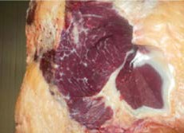
Abscess before removal of abscess. | Carcase after the removal.

To ensure Scotch Meat is produced to the highest standard:
- Use the neck injection technique, unless the product you use states otherwise.
- See diagram below for the safe area to inject into.
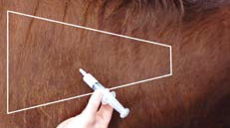 | 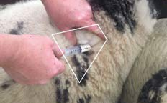
Contact your vet If you require additional advice of where to inject.

