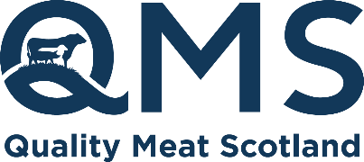
The Rural Centre, Ingliston
Newbridge, Midlothian, EH28 8NZ

Tel: 0131 510 7920
Email: info@qmscotland.co.uk
www.qmscotland.co.uk

QMS Briefing

Purpose: QMS response to ScotGov Local Food Consultation
Prepared By: Sarah Millar Director of Market Intelligence and External Affairs
Contact: smillar@qmscotland.co.uk
Date: 15/11/2021

Quality Meat Scotland is a Non-Departmental Public Body. This advice is provided under the Quality Meat Scotland Order 2008 Schedule 1 point 18 ’ Advising on any matters relating to the red meat sector (other than remuneration or conditions of employment) as to which the Scottish Ministers may request Quality Meat Scotland to advise, and undertaking inquiry for the purpose of enabling Quality Meat Scotland to advise on such matters ‘. This advice is freely available and further information can be provided by the designated contact above.

ScotGov local food Consultation- QMS Response

Question | Comment
- Do you agree with the Scottish Government definition of local food as set out in the strategy?
  - Yes
  - No
  - I don’t know

B. Please provide further detail on what local food means to you in the text box below.

