QUALITY MEAT SCOTLAND COMMUNITY MARKETING FUND
APPLICATION FORM
2024/25

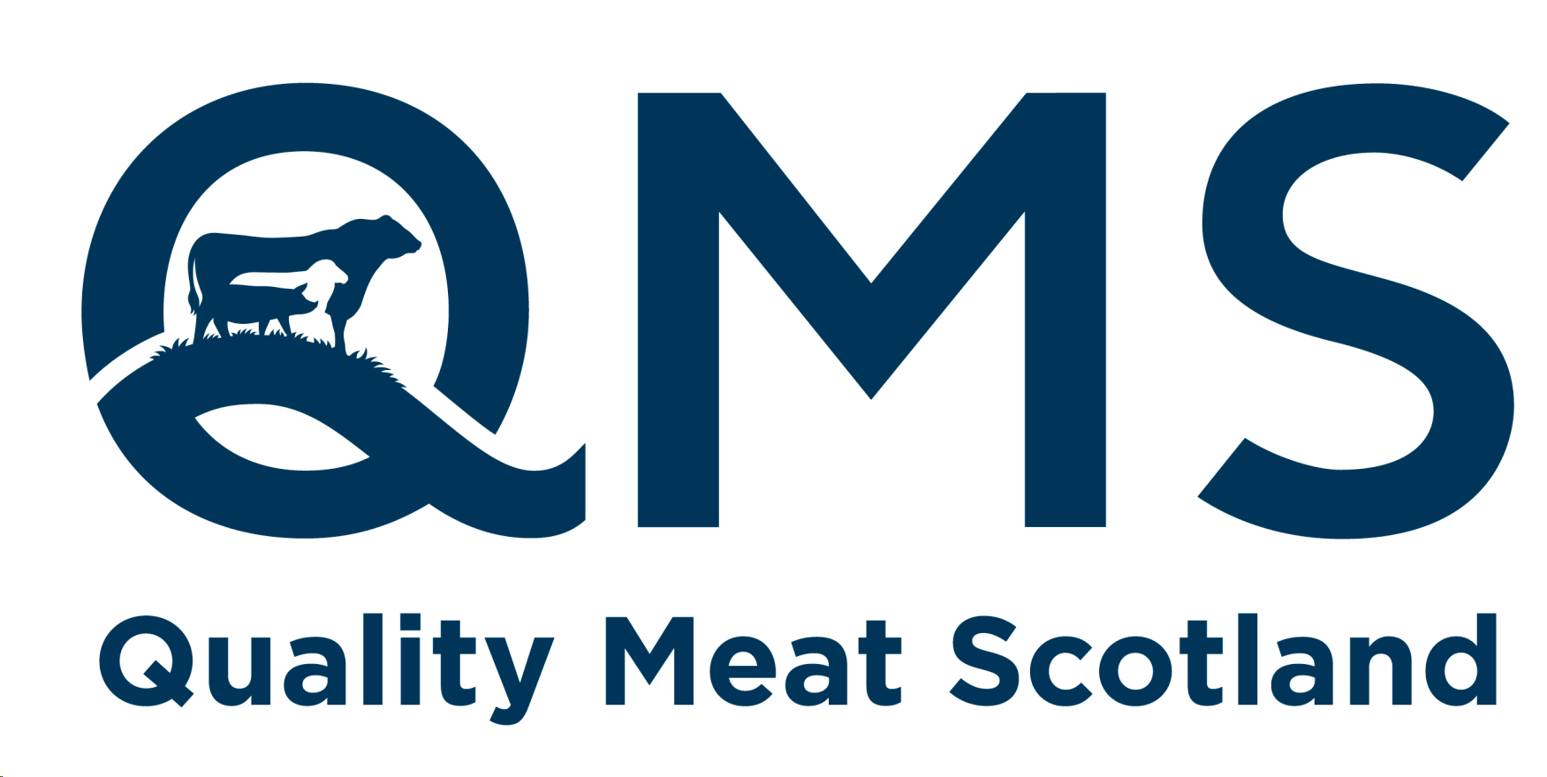
Please complete the following as accurately as possible and email the form to info@qmscotland.co.uk where we will aim to get back to you within 5 working days. We welcome applications from all community events but cannot guarantee that we can accommodate your request.
Your Name:
Email address:
Phone number:
Who are you applying on behalf of? (Please state organisation name as relevant):
A brief description of your request, what you need from QMS and when you need it by (eg.. Funding, sponsorship, meat, point of sale material, someone to speak at an event etc)…
What is the date, time and location of the event/initiative:
If relevant, how many people are you expecting will attend?
How will you evaluate the success of your initiative? What are you hoping to achieve from doing it? Please give a brief summary…
Anything else we should be aware of that may be helpful when considering your request?

