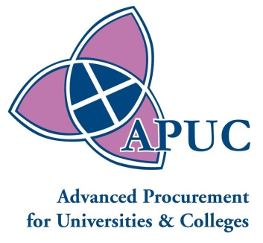

Opportunity to Supply Fresh Butcher Meat to Scotland’s Colleges and Universities

Notification of opportunity to tender
APUC, or Advanced Procurement for Universities and Colleges, is a company that has been set up by the Scottish Government for creating Framework Agreements on behalf of the Scottish Universities and Colleges.
A tender opportunity is about to be published for the supply of Fresh Butcher Meat to Scottish Universities and Colleges. The tender will be lotted geographically to enable local suppliers to submit tenders.
This tender will be announced on the Public Contracts Scotland website:
http://www.publiccontractsscotland.gov.uk/
The advertisement will be automatically transmitted to appear in the OJEU.
In order to take advantage of this and other public sector tender opportunities, you are advised to register as a supplier on Public Contracts Scotland. Registration is free. Once registered and your alerts set up, you will be automatically alerted by email as soon as the tender is advertised.
APUC will be using the Public Contracts Scotland Tender module to carry out the procurement process. This is a separate website and if you are not already registered, a short registration process will be required. Once registered, you will be able to download the relevant tender documents immediately after the tender is advertised.
https://www.publictendersscotland.publiccontractsscotland.gov.uk
APUC will be holding a free-to- attend Bidder Conference in Edinburgh on 4 September 2014, which will be open to all suppliers who have registered interest in this tender. The Bidders Conference is intended to provide an overview of the tendering procedure, helping to simplify the process and address relevant questions on the tender.
If you are interested in attending or would like further information about this tender, please contact Barbara Munro at APUC. (bmunro@apuc-scot.ac.uk)

