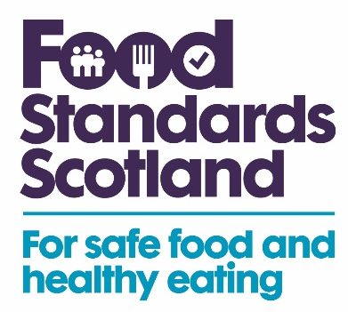

Registration/Approval Form

Application for registration or approval under Retained EU Feed Regulation (183/2005)

To: Food Standards Scotland
Pilgrim House, Old Ford Road, Aberdeen, AB11 5RL, feed@fss.scot

I am applying for the following premises to be registered / approved (delete as appropriate) under the above legislation. The information required is set out below.

1. Name or business name of the feed business to which this application relates. If the application relates to an existing registration or approval, enter the existing registration or approval number.
Name
Business Name
Registration or Approval Number

2. Address and associated details of the premises where the activity requiring registration or approval is undertaken or to be undertaken
Address
Phone |  | Fax
Email |  | Website
CPH Number (If applicable) |  | Assurance Scheme Membership

3. Activity or activities carried out on the premises (please use the code and activity descriptions shown in Annex 5.2 of Feed Manual)
Code(s): |  | Activity(ies):

4. Details of any Food Business activities at the Establishment (tick all that apply)
Food manufacturer
Supermarket
Brewer
Distiller
On farm food producer
Farm shop
Catering
Importer
Other (please specify):

5. Details of Seasonal activity – is the business only open at certain times of the year? If so, please provide details.

6. Applicant details
Name:
Address (if different from above):

Signature of Applicant |  | Date:

Feed business operators must also inform FSS of any changes to the name, business name, address, activity or ownership of a feed business establishment under its control, or its closure. In the event of temporary closure the Feed Business Operator is required to provide FSS with 2 weeks’ notice of re-opening.

Approval Fees

The Feed (Hygiene and Enforcement) (Scotland) regulations 2005 require that a business pay the relevant fee to Food Standards Scotland. The fees payable are:

Manufacture only, or manufacture and placing on the market, of feed additives referred to in Article 10(1)(a) of Regulation 183/2005 other than excluded additives or premixtures consisting solely of a combination of excluded additives - £451

Placing on the market of feed additives referred to in Article 10(1)(a) of Regulation 183/2005 other than excluded additives or premixtures consisting solely of a combination of excluded additives - £226

In addition, the business must reimburse the Food Standards Scotland on demand the cost of any laboratory analysis incurred by it in connection with the application.

Food Standards Scotland will issue an invoice for the above fees to the business upon submission of this application.

Supporting Documentation for Approval Application]

If not provided with the application, this information will be required at the time of the approval inspection.

Information to be considered for upload incudes:

A plan or plans of the establishment indicating:
- the layout of the establishment;
- the location of equipment;
- work flows for each product line; and
- pest control - baiting and/or trapping points within the establishment and external areas.
A synopsis of the establishment which briefly describes what type of establishment it is, products produced, volume of product, type of trade, number of employees, and, if already approved, approval number and what it is approved for. This synopsis should be no more than one side of an A4 sheet.

Intervention reports on premises in chronological order.
Copies of notices or other formal action taken in chronological order.

Copy of company’s emergency withdrawal plan and traceability system including names, telephone numbers, etc., of key personnel within the company.

Location of any off-site facilities.
Copy of any other documents that have been provided by, or copied at, the approved premises, including:
- HACCP documentation;
- product list;
- raw material, product sampling plans and test results;
- process records;
- management and key contact names and contact details;
- photographs and digital images; and
- product recall procedures

Privacy Statement
Your personal information will be collected by Food Standards Scotland as required by Retained EU Regulation 183/2005. This is be done in line with the General Data Protection Regulations (GDPR) and Data Protection Act 2018. For further information about how FSS handles your personal information, refer to our Privacy Notice on FSS website.

