SCOTCH BUTCHERS CLUB MEMBERSHIP RENEWAL

2018/19

Company Information:

Name:
(Shop Owner/Manager)
Company/Trading Name:
(This will appear on certificate)
Address:

Email:
Telephone No:

Current Supplier(s) Information:
(Source Abattoir/Processor or Wholesaler)

Scotch Beef PGI:
Scotch Lamb PGI:
Specially Selected Pork:

Declaration:

By renewing your membership, you confirm that you continue to be a stockist of Scotch Beef PGI, Scotch Lamb PGI and/or Specially Selected Pork.

A list of QMS approved abattoirs and processors are available on request and on the QMS website: http://www.qmscotland.co.uk/.

Please note that many Scottish abattoirs do not exclusively kill Scotch and/or Specially Selected products. Care must be taken to specifically order Scotch Beef PGI, Scotch Lamb PGI and/or Specially Selected Pork.

Members of the Scotch Butchers Club are automatically registered within the Quality Meat Scotland Quality Assurance Scheme allowing you to use the Scotch Beef PGI, Scotch Lamb PGI and Specially Selected Pork labels. This registration covers usage of the label on primal cuts and ‘Made with’ on processed/manufactured products. By joining the club, members agree to an unannounced visit to their premises in order to audit their traceability records and allow QMS to contact their stated supplier to verify supply. By signing and dating the declaration you agree to comply with the terms and conditions as provided to you, these are also available on request from Quality Meat Scotland.

If you have any questions about The Scotch Butchers Club, please do not hesitate to get in touch with Graeme Sharp (Marketing Executive) via phone: 0131 472 4042 or via email: gsharp@qmscotland.co.uk.

Signature……………………………………………………………. Date…………………….

SCOTCH BUTCHERS CLUB CATERING CERTIFICATES

Please provide full details of catering customers requiring a Catering Certificate and state whether you supply them with Scotch Beef PGI, Scotch Lamb PGI and/or Specially Selected Pork. A separate certificate will be issued for each species:

Customer Name | Telephone | Supplied with Scotch Beef, Scotch Lamb or Specially Selected Pork?

- Please note that by applying for Catering Certificate you are stating that you are currently and will continue to supply your catering customer listed above with Scotch Beef PGI, Scotch Lamb PGI and/or Specially Selected Pork for the year 2018/19.
- Your catering customers must be able to clearly differentiate Scotch and or Specially Selected from other meat products they may serve.
- It is your responsibility to make sure the certificate is not used in a way that could create confusion.
- You must indicate to your catering customers that the terms Scotch Beef PGI, Scotch Lamb PGI and/or Specially Selected Pork must be used at all times. You must also be able to supply your catering customer with proof of full traceability.
- You must supply your customers with invoices and delivery notes that specify if the product is Scotch and/or Specially Selected.
- If your catering customer is currently a member of the Scotch Beef Club a Scotch Butchers Club catering certificate will not be issued. They will receive one directly from the Scotch Beef Club.

Please sign and date the below to confirm you have read and understand the terms and conditions in regards to the Catering Certificates.

Signature……………………………………………… Date…………………

Please note catering certificate requests should be sent in by no later than 30th June 2018.
Scotch Butchers Club Vouchers:

Quality Meat Scotland (QMS) on a regular basis makes available Scotch Butchers Club meat vouchers for competition winners and bloggers UK wide as well as Secondary Schools in Scotland. The vouchers offer you a great opportunity to win over a new customer, all we ask is that you accept the voucher and return it with an accompanying invoice. If you are able and willing to accept a voucher, please tick YES in the box below.

Yes, I can accept QMS/Scotch Butchers Club vouchers

No, I am not able to accept QMS/Scotch Butchers Club vouchers

An Example Scotch Butchers Club Voucher (below):

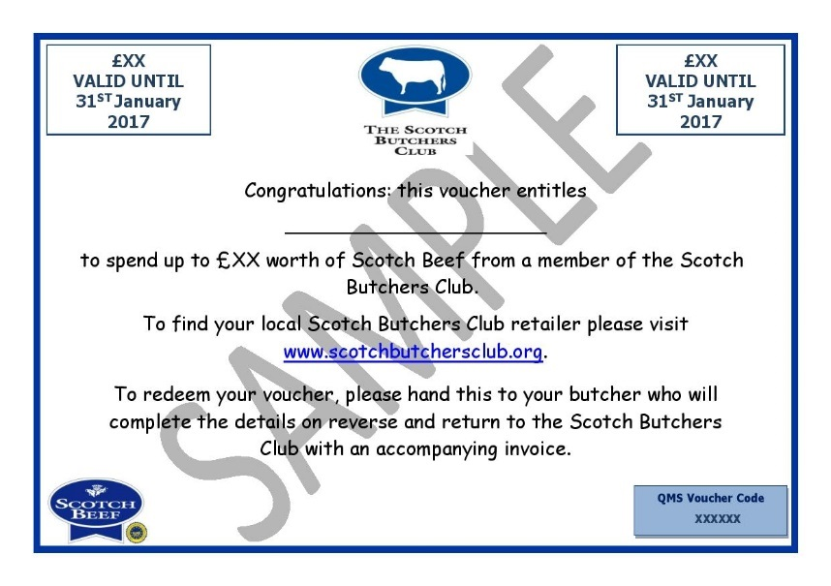

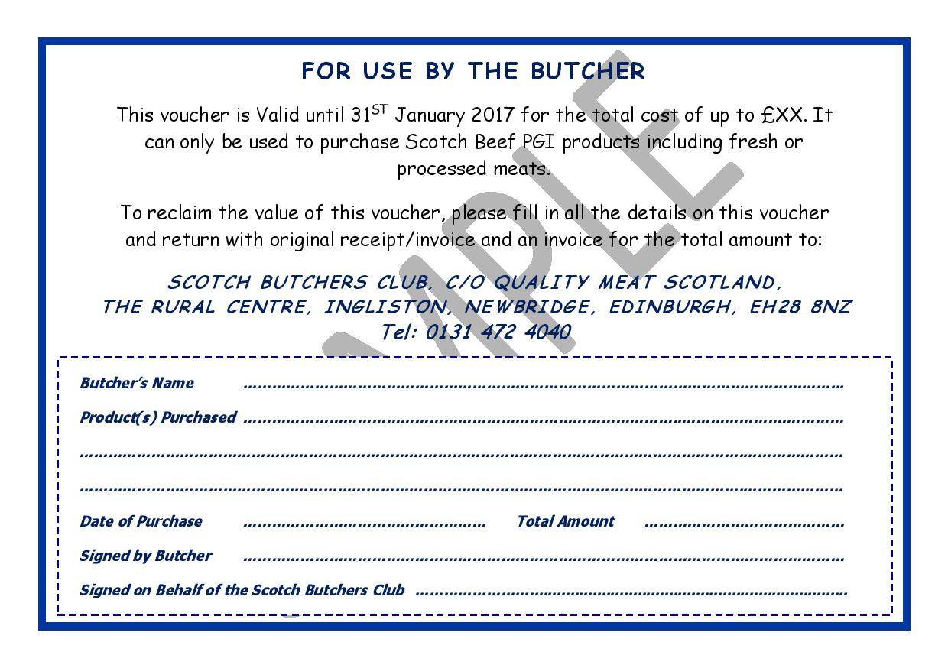

Payment Information:

Please complete and return along with your payment in the pre-paid envelope provided.

I enclose a cheque for £75 (inclusive of VAT) for Standard Membership made payable to QUALITY MEAT SCOTLAND.

Please make cheques payable to Quality Meat Scotland

BACS Transfer Payment Details

If you would prefer to pay by BACS transfer, please use the following account details.

Bank: Bank of Scotland Account Name: Quality Meat Scotland
28 Roseburn Terrrace Account No: 00564379
Edinburgh Sort Code: 80-02-78
EH12 6AW
Standard Membership £75.00
Membership Plus £150.00

Date of BACS Payment ……………………………

*Members paying via BACS must quote their Membership ID or Business Name as the reference so that your payments can be identified accordingly. *

Credit /Debit Card Payment

If you would prefer to pay by credit or debit card this is possible by phone. Please use the following number: 0131 472 4040. Please note that payment will not be accepted unless a completed renewal form has been sent in.

A receipted VAT invoice, together with your certificates, will be issued once your renewal has been approved.

